MEDIA ALERT FOR IMMEDIATE RELEASE

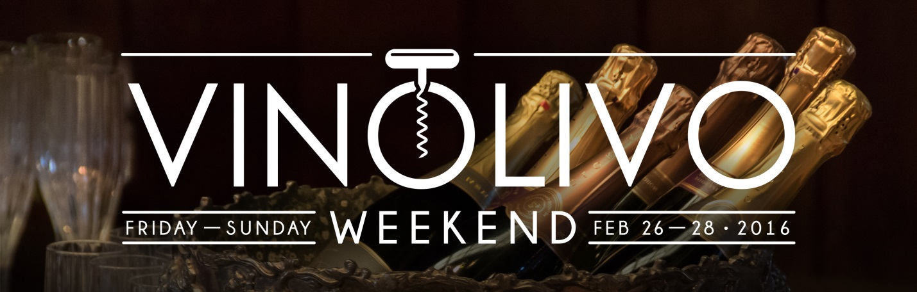

VINOLIVO WEEKEND Set for February 26-28th, 2016
Tickets Now on Sale for Sonoma Valley’s Epicurean Event of the Year

Sonoma, Ca (January 15, 2016) Tickets are on sale now for the 11th Annual VINOLIVO Weekend presented by the Sonoma Valley Vintners & Growers Alliance (SVVGA). VINOLIVO Weekend gathers more than 60 wineries and 25 top restaurateurs for a festive celebration of Sonoma Valley’s many epicurean delights. Friday night’s signature Grand Tasting is the valley’s largest annual winetasting event, celebrating Sonoma Valley’s unique heritage as the birthplace of California’s wine industry.

VINOLIVO Weekend: Grand Tasting
Friday, February 26th from 7:00 – 10:00pm at The Renaissance Lodge at Sonoma Resort & Spa

One of the most anticipated wine events of the season, the signature VINOLIVO Grand Tasting kicks off the weekend in style with an epicurean celebration of Sonoma Valley.

— Sip your way through the elegant sparkling wines being poured in the Bubble Room
— Explore the latest vintages from Sonoma Valley’s world-class wineries
— Mingle with the passionate winemakers and chefs behind the evening’s incredible offerings
— Indulge in the tasty creations of Sonoma’s finest restaurateurs, caterers, and culinary artisans

Participating Wineries & Culinary Purveyors:
Anaba Wines ~ Annadel Estate Winery ~ Arrowood Winery ~ AUTEUR ~ Aventine Glen Ellen ~ Bartholomew Park Winery ~ B.R. Cohn Winery ~ Beltane Ranch ~ Bennett Valley Cellars ~ Benziger Family Winery ~ BRYTER Estates ~ B&V Whiskey Bar & Grille ~ Ceja Vineyards ~ Chateau St. Jean ~ Cline Family Cellars ~ Corner 103 ~ Crisp Bakeshop ~ Dane Cellars ~ Deerfield Ranch Winery ~ El Dorado Kitchen ~ GlenLyon Winery ~ Gloria Ferrer Caves & Vineyards ~ Highway 12 Vineyards and Winery ~ Hopmonk Tavern ~ Idell Family Vineyards ~ Imagery Estate Winery ~ Jacuzzi Family Vineyards ~ Keating Wines ~ Kenwood Vineyards ~ Kivelstadt Cellars ~ KRAVE Jerky ~ Lake Sonoma Winery ~ Landmark Vineyards ~ La Rochelle Wines ~ Larson Family Winery ~ Laurel Glen Vineyard ~ Ledson Winery & Vineyards ~ Loxton cellars ~ MacLeod Family Vineyard ~ Madrone Vineyards Estate ~ Mayo Family Winery ~ Meadowcroft ~ Muscardini Cellars ~ Olive & Vine ~ Petroni Vineyards ~ Ravenswood ~ Schug Carneros Estate Winery ~ Sebastiani Vineyards & Winery ~ Sojourn Cellars ~ Sonoma Market ~ St. Francis Winery ~ Talisman Wines ~ Three Sticks Wines ~ the girl & the fig CATERS! ~ The Red Grape ~ Tin Barn Vineyards ~ Two Amigos Winery ~ Victor Hill Wines ~ WALT Wines ~ Westerhold Family Vineyards
**Additional Winery and Culinary Participants are being added daily**

Tickets are $75 General Admission in advance and $85 at the door, a $95 VIP ticket is also available for advance purchase, granting early (6:30 PM) admission to the tasting event.
For tickets visit www.sonomavalleywine.com or call 707-935-0803.

VINOLIVO Weekend: Winemaker Dinners
Saturday, February 27th | 7:00PM
$150 per person (limited availability)

Enjoy an intimate dining experience hosted by some of Sonoma Valley’s finest winemakers and culinary artists. Experience multiple courses of memorable wine and food pairings, while enjoying the company of fellow wine and food enthusiasts. Confirmed pairings for 2016 include:

Annadel Estate Winery & Aventine Glen Ellen
B.R. Cohn Winery & Ramekins Culinary School (Held at General’s Daughter)

VINOLIVO Weekend: Ticket to Sonoma Valley tasting pass gives ticket-holders special access to over 40 Sonoma Valley wineries. Pass-holders will receive a menu of special offers, varying from winery to winery ranging from complimentary tastings and discounted wine pricing, to barrel tastings and winery tours. The 3-Day Ticket to Sonoma Valley can be used Friday, February 26th – Sunday, February 28th at participating wineries throughout Sonoma Valley at a cost of $50 per person. A 1-Day Ticket to Sonoma Valley option is available for $25 per person, allowing guests to select one day out of the three available to enjoy their special access. For tickets visit www.sonomavalleywine.com or call 707-935-0803.

VINOLIVO Weekend: VIP Ticket Package includes early VIP access to the Grand Tasting event on Friday night and a 3-day Ticket to Sonoma Valley tasting pass, for an all-inclusive price of $130. Package tickets must be purchased by February 24th, 2016 at 3:00pm. For tickets visit www.sonomavalleywine.com or call 707-935-0803.

VINOLIVO Weekend: Online Auction returns for 2016 offer ing uniquely special winery and vacation experiences, and, of course, plenty of world-class wines from Sonoma Valley! The VINOLIVO Weekend Online Auction begins on January 25th and closes February 29th. For details visit www.sonomavalleywine.com.

About SVVGA
About Sonoma Valley Vintners & Growers Alliance and Sonoma County Vintners: The Sonoma Valley Vintners & Growers Alliance (SVVGA) is a non-profit organization serving over 500 members who share a mission to promote awareness of Sonoma Valley’s grapes, wine and history as the birthplace of the California wine industry. Sonoma Valley comprises five of the seventeen American Viticulture Areas (AVAs) of Sonoma County: Bennett Valley, Los Carneros, Moon Mountain District, Sonoma Mountain and Sonoma Valley. To learn more about the SVVGA visit http://www.sonomavalleywine.com or call 707-935-0803.

###

