FOR IMMEDIATE RELEASE
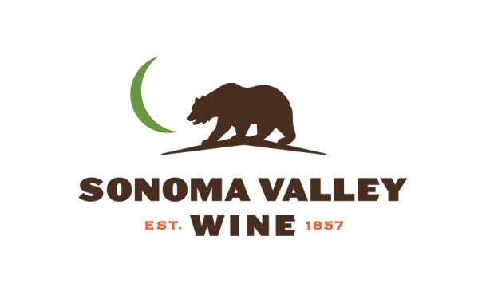
SONOMA VALLEY VINTNERS & GROWERS ALLIANCE
ANNOUNCES 2016 BOARD LEADERSHIP

SONOMA, CA (January 20, 2016) The Sonoma Valley Vintners & Growers Alliance (SVVGA) non-profit trade association representing over 100 wineries and 140 grape growers announced yesterday that vintner Kenneth Juhasz, proprietor and winemaker of Auteur Wines, has been elected to lead the organization as board president for 2016.

“I am honored to lead the board of the Sonoma Valley Vintners and Growers and I look forward to continuing the tradition of the leadership established by those who have come before me. The organization has a great commitment to our wine community and we look forward to continuing that excellence through the marketing and membership programs we have in place in 2016” said Juhasz.

Other board officers elected include Alan Ross of Ross Vineyard as Vice President; Bill Hooper of Tyge William Cellars as Treasurer and Lauren Benward Krause of Beltane Ranch as Secretary. New 2016 board directors are Prema Behan of Three Sticks Wines, Steven Sangiacomo of Sangiacomo Family Vineyards, and Jonny Westom of Sonoma Valley Visitors Bureau.

The complete 2016 SVVGA board includes: Kenneth Juhasz, President – Auteur Wines; Alan Ross, Vice President – Ross Vineyard; Bill Hooper, Treasurer – Tyge William Cellars, Lauren Benward Krause, Secretary – Beltane Ranch; Prema Behan – Three Sticks Wines; Gary Buffo, Pure Luxury Transportation; Rick Corcoran – Fairmont Sonoma Mission Inn & Spa; Danny Fay – Corner 103; Richard Idell – Idell Family Vineyards; Jon Parker – Highway 12 Vineyards & Winery; Steven Sangiacomo – Sangiacomo Family Vineyards; Jonny Westom – Sonoma Valley Visitors Bureau; Dan Zepponi – Madrone Vineyards Estate.

About SVVGA
The Sonoma Valley Vintners & Growers Alliance (SVVGA) is a non-profit organization serving over 500 members who share a mission to promote awareness of Sonoma Valley’s grapes, wine and history as the birthplace of the California wine industry. Sonoma Valley comprises five of the seventeen American Viticulture Areas (AVAs) of Sonoma County: Bennett Valley, Los Carneros, Moon Mountain District, Sonoma Mountain and Sonoma Valley. To learn more about the SVVGA visit http://www.SonomaValleyWine.com or call 707-935-0803.

###

Media:
Maureen L. Cottingham
info@sonomavalleywine.com
www.SonomaValleyWine.com
707-935-0803 x 1

